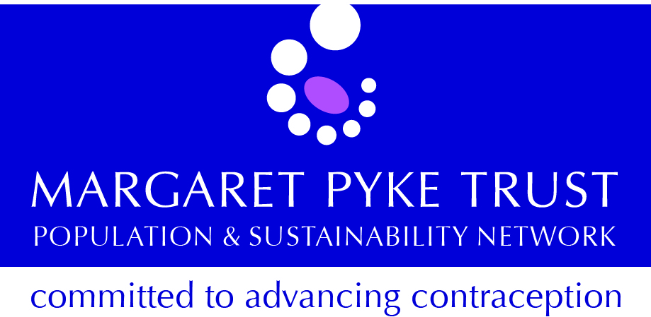

SRH Essentials - for Practice Nurses:
Tuesday 13th June 2017

Venue: Stephenson Harwood LLP
1 Finsbury Circus
London EC2M 7SH
(full details on the next page)

Programme

09.00 – 09.30 Registration and Refreshments

09.30 – 09.50 Introduction

09.50 – 11.00 Emergency Contraception

11.00 – 11.15 Coffee Break

11.15 – 11.45 Emergency Contraception continued

11.45 – 12.30 STIs

12.30 – 13.15 Sandwich Lunch

13.15 – 14.20 STIs continued

14.20 – 15.00 Contraception

15.00 – 15.30 Tea Break

15.30 – 16.45 Contraception continued

16.45 – 17.00 Evaluation

17.00 Close

The fee to attend is £160.00 for the day’s training, including all refreshments and a sandwich lunch. To book online please go to:

http://www.margaretpyke.org/training/SRHEssentials.html

Contact details: Rosemary Massouras, Director of Training
rosemarymassouras@margaretpyke.org; 020 3317 5497 / 07779 306 805

This event is being hosted by Stephenson Harwood LLP whose splendid offices at Finsbury Circus were designed by the famous architect Edwin Lutyens. We are grateful for their generosity. Click here for directions:

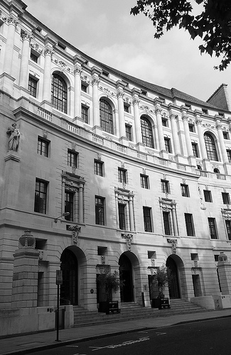
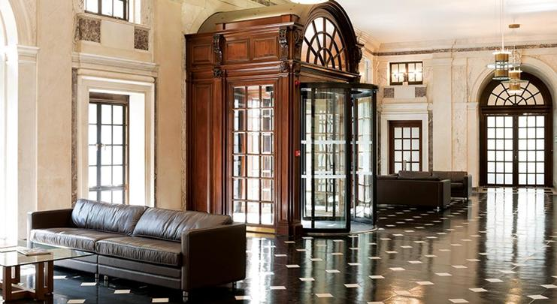

This course is being run by the Margaret Pyke Trust, a charity that has been running
training courses in sexual and reproductive healthcare since 1969. The Trust has been approved as a provider of this training by the Faculty of Sexual and Reproductive Healthcare by whom the course was designed.

